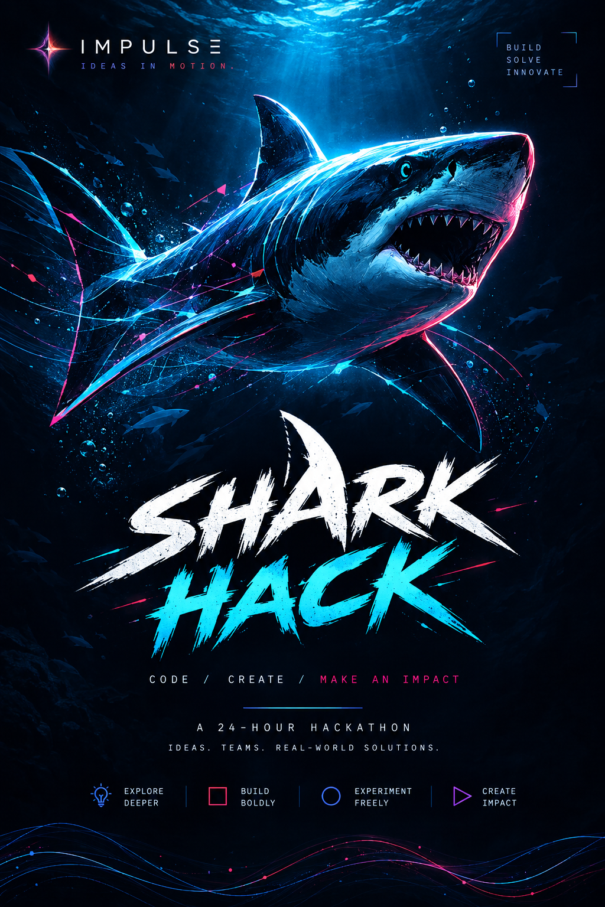
IMPULSE PRESENTS
🦈 SHARK HACK
DON’T JUST BUILD. MAKE THEM BELIEVE.
An All-India Hackathon where technical execution meets pitching, product thinking and live negotiation.
30 -31OCTOBER 2026 · DELHI
₹1,00,000+ PRIZE POOL · OFFLINE GRAND ROUND · IMPULSE CREDITS · LIVE DEAL ROOM
Team Size: 2–4 participants

01 — THE BIG IDEA
What exactly is SHARK HACK?
Most hackathons follow a familiar formula:
Problem → Build → Pitch → Judge → Winner
SHARK HACK changes the final part.
Here, building a working prototype is only the beginning.
Teams will receive the official problem statement on 20 September/October [FINAL DATE TO CONFIRM], develop their solution, submit their required presentation before the deadline, and compete for a place in the offline grand round.
The shortlisted teams will then enter the SHARK ROOM.
This is where things get different.
Teams will:
- Present their solution.
- Demonstrate their prototype.
- Explain the problem they are solving.
- Defend their USP.
- Answer questions from the judges.
- Communicate the value of their product.
- Receive offers in Impulse Credits.
- Negotiate.
- Counter.
- Defend their valuation.
- And ultimately attempt to close the deal.
The central question of SHARK HACK:
Can you build something valuable — and then convince someone else that it is worth backing?
Because in the real world, a technically brilliant product still needs people who can explain it, sell it, defend it and make others believe in it.

02 — WHY SHARK HACK?
Hackathons usually test whether you can build.
SHARK HACK asks a bigger question.
Can you build AND communicate value?
A team might have:
Great Code + Weak Pitch
and struggle to make anyone care.
Another might have:
Great Idea + Weak Execution
and fail to convince the room.
Another might have:
Strong Prototype + Strong Pitch + No Clear USP
and get challenged immediately.
SHARK HACK brings all of these skills into one arena.
WE TEST:
TECH
Can you actually build?
PROBLEM SOLVING
Did you understand the problem deeply?
PRODUCT THINKING
Does your solution genuinely address the problem?
INNOVATION
What makes your approach different?
USP
Why should someone choose your solution?
COMMUNICATION
Can you make people understand it quickly?
BUSINESS THINKING
Can you explain why the solution matters?
NEGOTIATION
Can you defend your value under pressure?

03 — THE SHARK HACK EXPERIENCE
From registration to the Shark Room
The journey is designed in stages.
STAGE 01 — REGISTER
Participants register individually/team-wise through the official registration form.
TEAM SIZE
2–4 members per team
The registration process should collect:
- Team name
- Team leader
- Team members
- College/institution
- Contact details
- Relevant technical domains
- Previous project/building experience, if required by the organizing team
- Other information required for screening/logistics
Important: Participants are not required to submit a PPT or solution during registration.
Registration should remain simple and accessible.

04 — THE DATE OF SUBMISSION ( THIS PART IS TENTATIBE JUST TO GIVE YOU GUYS AN IDEA)
THE CLOCK STARTS NOW.
On 20 October 2026 [confirm date], SHARK HACK will officially CL
This is the moment the competition changes.
Until the problem is released, teams don't know exactly what they will be building for.
Once the problem drops:
The building begins.
Teams will need to:
- Understand the problem.
- Identify the target users.
- Research the space.
- Develop their approach.
- Design the solution.
- Build a prototype/MVP.
- Test and iterate.
- Prepare their presentation.
- Prepare for questioning.
- Submit their PPT before the announced deadline.

05 — THE SUBMISSION ROUND
BUILD. DOCUMENT. SUBMIT.
After the problem statement is released, teams will work on their proposed solution.
The team will submit the required presentation/documentation before the official deadline.
The submission should allow the organizing/judging team to understand:
01. THE PROBLEM
What exactly are you solving?
02. THE USER
Who experiences this problem?
03. YOUR SOLUTION
What have you built?
04. HOW IT WORKS
What is the actual mechanism/product flow?
05. THE PROTOTYPE
What can we see, test or demonstrate?
06. INNOVATION
What is different about your approach?
07. USP
Why does your solution stand out?
08. IMPACT
What changes if your solution succeeds?
09. FEASIBILITY
Can this realistically be implemented?
10. FUTURE POTENTIAL
Where could this go beyond the hackathon?

06 — SHORTLISTING
NOT EVERY TEAM ENTERS THE SHARK ROOM.
After submissions close, the Impulse organizing and judging team will evaluate the submissions according to the officially published criteria.
The strongest teams will be shortlisted for the offline round in Delhi.
Suggested screening criteria
Criterion | What we look for
Problem Understanding | Depth of understanding
Solution Quality | Relevance and effectiveness
Innovation | Originality of approach
Technical Feasibility | Can it actually work?
Prototype/MVP | Quality of implementation
USP | Clear differentiation
Impact | Potential usefulness
Product Thinking | User-centricity and practicality
Presentation | Clarity and structure
Important operational note: Final scoring weights should be frozen and published internally before submissions are evaluated.

07 — THE OFFLINE ROUND
WELCOME TO THE SHARK ROOM.
The shortlisted teams come to Delhi.
This is no longer just a presentation.
This is where the SHARK HACK experience begins.
Teams will have the opportunity to present their solutions directly in front of the judging panel.
The room should feel different from a conventional hackathon.
Think:
STARTUP PITCH ROOM × HACKATHON × DEAL FLOOR
The atmosphere should be energetic, competitive and interactive.

08 — THE PITCH
FIRST, MAKE THEM LISTEN.
Each team gets a defined amount of time to present.
The pitch should cover:
PROBLEM
What problem are you solving?
INSIGHT
Why does this problem matter?
SOLUTION
What did you build?
DEMO
Show us.
USP
Why is your solution different?
IMPACT
Who benefits?
SCALE
Where can this go?
THE ASK
Why should the Sharks back your solution?

09 — THE SHARKS
THEY DON'T JUST SIT AND SCORE.
The judges aren't simply there to listen to a presentation and fill out a sheet.
They become the Sharks.
Their role is to challenge the teams.
They can ask questions such as:
“Why would users actually switch to this?”
“What's stopping someone from copying this?”
“Why does this need AI?”
“What's your biggest technical limitation?”
“Who is actually paying for this?”
“What makes this scalable?”
“Why is your solution better than the obvious alternative?”
The goal is not to intimidate participants.
The goal is to test whether teams understand the value of what they built.

10 — IMPULSE CREDITS
THE CURRENCY OF SHARK HACK.
Instead of real money, the Shark Room operates using Impulse Credits.
Impulse Credits are a game/competition mechanism used by judges to express the value they place on a team's solution.
They allow the final round to become interactive.
Instead of simply hearing:
“Team A scored 87.”
participants experience:
“The Sharks are willing to put 12,000 credits behind this idea.”

11 — THE DEAL
A typical interaction could look like:
SHARK:
“I'll offer 8,000 Impulse Credits.”
TEAM:
“We believe the solution justifies more because of our technical differentiation and scalability.”
SHARK:
“10,000.”
TEAM:
“We can close at 12,000.”
SHARK:
“Done.”
DEAL.
The exact mechanics — including whether multiple Sharks can make offers, whether teams can receive multiple offers, how credits are recorded and how deals translate into final scores — must be finalized and published in the official rulebook.

12 — WHAT DOES “SELLING” MEAN?
SHARK HACK is not asking participants to literally sell their company.
They are selling the value of the solution they built.
A strong team should be able to answer:
Why this problem?
Why this solution?
Why now?
Why you?
Why is it different?
Why will users care?
Why can it work?
Why should the Sharks back it?
This is the heart of SHARK HACK.

13 — THE FOUR-PHASE MODEL
BUILD → PITCH → NEGOTIATE → CLOSE
01 — BUILD
Turn the problem statement into a working solution.
↓
02 — PITCH
Make the room understand why your solution matters.
↓
03 — NEGOTIATE
Defend your value when the Sharks challenge you.
↓
04 — CLOSE
Convert your pitch into a deal.

14 — WHAT MAKES SHARK HACK DIFFERENT?
NORMAL HACKATHON
Build
↓
Submit
↓
Present
↓
Judging
↓
Winner
SHARK HACK
Register
↓
Problem Drop
↓
Build
↓
Submit
↓
Shortlisting
↓
Offline Round
↓
Pitch
↓
Questioning
↓
Offer
↓
Counteroffer
↓
Negotiation
↓
DEAL
That's the experience we are designing.

15 — WOMEN IN TECH
BUILT BY WOMEN. OPEN TO BUILDERS EVERYWHERE.
SHARK HACK is being organized by an all-women Impulse organizing team.
The event is designed not only as a technical competition, but also as a space where women can be visible in:
- Technology
- Product building
- Entrepreneurship
- Leadership
- Pitching
- Negotiation
- Business
The main hackathon remains open to eligible participants.
Additionally, SHARK HACK will feature a dedicated:
🏆 WOMEN-IN-TECH PRIZE
for eligible all-women teams.
The objective isn't simply to put women on stage.
It is to create a room where women are:
BUILDING. PITCHING. NEGOTIATING. LEADING.

16 — PARTICIPANT PSYCHOLOGY
This should be the emotional journey of the event.
REGISTRATION
“Let's apply.”
↓
PROBLEM DROP
“Okay. This is the problem.”
↓
BUILD
“Can we actually make this work?”
↓
SUBMISSION
“Is this good enough to get shortlisted?”
↓
SHORTLIST
“WE'RE GOING TO DELHI.”
↓
PITCH
“Now we have to make them believe.”
↓
SHARK QUESTIONS
“Okay… they are really testing us.”
↓
OFFER
“Wait. They're actually offering credits.”
↓
NEGOTIATION
“We're not taking that. Here's why we're worth more.”
↓
DEAL
“CLOSED.”
That emotional progression should be reflected in the branding, venue, MC script, social media and stage design.

17 — EVENT DAY STRUCTURE
A suggested structure for the offline grand round:
ARRIVAL
Team check-in
↓
Welcome kit
↓
Team briefing
↓
Shark Room orientation
OPENING
Host introduction
↓
Impulse introduction
↓
SHARK HACK concept reveal
↓
Rules + scoring explanation
PITCH ROUND
Team 01
↓
Pitch
↓
Demo
↓
Shark Q&A
↓
Offer
↓
Negotiation
↓
Deal
Repeat for all shortlisted teams.
BREAK / INTERACTION
Networking
Sponsor activations
Photography
Community interaction
FINAL ROUND / CLOSING
Final deals / scoring verification
↓
Judge deliberation
↓
Results
↓
Prize distribution
↓
Winner photographs

18 — VISUAL IDENTITY
THE DESIGN LANGUAGE
SHARK HACK should feel like:
Technology × Startup × Competition × Deal Room
Suggested visual direction
Dark base
- Electric purple
- Neon cyan
- Magenta
- High-contrast white
- Small yellow/gold accents for credits
Graphic language
🦈 Shark silhouette
💳 Impulse Credit coins
📈 Deal/valuation graphics
⚡ Digital grids
🎯 Target/USP visuals
💬 Speech bubbles
🤝 Deal/handshake motifs
🔥 Pitch-room energy
Avoid making it look like a generic:
“Code. Innovate. Collaborate.”
hackathon poster.
The branding should immediately communicate:
Something unusual is happening here.

19 — SOCIAL MEDIA POSITIONING
The event should be marketed as an experience, not just another hackathon.
Possible campaign hooks:
“What if your hack had to survive a Shark?”
“Build it. Pitch it. Defend it. Close it.”
“Your code gets you into the room. Your pitch gets you the deal.”
“The problem drops. The clock starts.”
“You built it. Now convince the Sharks.”
“Not every great hack wins. Can yours make the deal?”

20 — PARTICIPANT VALUE PROPOSITION
Why should someone participate?
01 — BUILD FOR A REAL CHALLENGE
Teams work on a problem revealed specifically for the competition.
02 — OFFLINE EXPERIENCE
Shortlisted teams get to compete physically in Delhi.
03 — PITCH IN FRONT OF JUDGES
Participants experience a high-pressure pitch environment.
04 — NEGOTIATE
Participants don't simply receive marks.
They have to defend the value of their solution.
05 — WIN ₹1,00,000+
A substantial prize pool gives the competition real stakes.
06 — NETWORK
Connect with builders, mentors, judges, industry professionals and fellow students.
07 — SPECIAL WOMEN-IN-TECH RECOGNITION
Dedicated opportunity for eligible all-women teams.

22 — RULEBOOK: THINGS WE MUST FINALIZE
Before registrations open, the Impulse core team needs one locked master rulebook.
It should define:
Registration
- Eligibility
- Team size: 2–4
- Individual/team registration process
- College requirements
- Multiple-team participation rules
Problem Statement
- Exact release date
- Release platform
- Clarification mechanism
- Whether all teams receive the same problem
- Whether sub-themes exist
Submission
- PPT format
- Number of slides
- Submission deadline
- Prototype requirements
- GitHub/demo requirements
- Late submission policy
- File naming convention
Shortlisting
- Number of teams selected
- Evaluation criteria
- Judges
- Conflict-of-interest policy
- Tie-breaker
Offline Round
- Reporting time
- Pitch duration
- Demo duration
- Q&A duration
- Number of Sharks
- Deal duration
Impulse Credits
This is particularly important.
The rulebook must define:
- Starting credits for each Shark
- Whether all Sharks receive equal credits
- Whether credits are visible
- Minimum/maximum offer
- Whether Sharks can collaborate
- Whether a team can accept multiple offers
- Whether a team can reject an offer
- Whether teams can counter
- Whether deals are binding
- How deals are recorded
- What happens if no deal is made
- How credits contribute to final ranking
- Tie-breaker mechanism
Final Winner
The exact scoring formula must be transparent.
Do not leave the final winner dependent on an informal “who negotiated better” decision.
The negotiation mechanic should be exciting, but the underlying scoring needs to be objective and auditable.

23 — INTERNAL TEAM PRINCIPLE
Everyone working on SHARK HACK should understand:
We are not just organizing a hackathon. We are designing an experience.
Every decision should pass three questions:
Does it make the event clearer?
Does it make the event more exciting?
Does it make the participant experience smoother?
If something makes the event complicated without adding value, remove it.

24— CONTINGENCY PLANNING
Because this is the first large-scale event, SHARK HACK needs backup plans before event day.
IF VENUE IS DELAYED
Maintain at least one confirmed backup venue.
IF SPONSOR FUNDING IS DELAYED
Separate:
Cash commitments
from
in-kind prizes
so the event can continue even if one sponsor is delayed.
IF A JUDGE CANCELS
Maintain backup judges.
IF INTERNET FAILS
Prepare:
- Offline presentations
- Local demo videos
- Backup hotspots
- Offline copies of submissions
IF A TEAM'S DEMO FAILS
Allow a clearly defined backup demo mechanism.
IF SCORING DISAGREEMENT OCCURS
Have a predefined scoring/tie-break process.
IF A TEAM BREAKS RULES
Have a documented escalation/disqualification policy.

25— SPONSOR VALUE
SHARK HACK gives sponsors more than logo placement.
Potential sponsor integrations:
TITLE SPONSOR
“SHARK HACK powered by ___”
SHARK SPONSOR
Sponsor-backed judge/shark
CREDIT PARTNER
“Impulse Credits powered by ___”
PRIZE PARTNER
Dedicated prize category
WOMEN-IN-TECH PARTNER
Supports the Women-in-Tech Prize
TECHNOLOGY PARTNER
Cloud credits / APIs / developer tools / infrastructure
COMMUNITY PARTNER
Outreach and participant ecosystem

26 — WHAT WE WANT THE AUDIENCE TO FEEL
When someone enters the venue, the reaction should be:
“This is not a normal college hackathon.”
When a team walks onto the stage:
“Now they have to prove it.”
When a Shark makes an offer:
“Wait—what happens now?”
When the team counters:
“OH. THEY'RE NEGOTIATING.”
When the deal closes:
“DEAL!”
That is the experience we are trying to create.

27 — THE NORTH STAR
At the end of SHARK HACK, a participant should leave thinking:
“I didn't just build a project today. I learned how to make people believe in what I built.”
And the audience should leave thinking:
“I want to be on that stage next time.”
And the Impulse team should be able to say:
“We created something people will remember.”

28 — FINAL EVENT POSITIONING
🦈 SHARK HACK
DON'T JUST BUILD. MAKE THEM BELIEVE.
An all-India hackathon by Impulse where teams don't stop at building a solution.
They build.
They pitch.
They defend.
They negotiate.
They close.
BUILD → PITCH → NEGOTIATE → CLOSE
30-31 OCTOBER 2026 · DELHI (venue ki availability k hisab se one date will be taken)
TEAM SIZE: 2–4
₹1,00,000+ PRIZE POOL
IMPULSE CREDITS
OFFLINE GRAND ROUND
WOMEN-IN-TECH PRIZE

INTERNAL ONE-LINE DEFINITION
For anyone on the Impulse team who needs to explain SHARK HACK quickly:
SHARK HACK is an all-India hackathon where teams build a solution for a surprise problem, compete for an offline final, and then pitch, defend and negotiate the value of their solution with judges using Impulse Credits.
And the simplest version:
Build it. Pitch it. Negotiate it. Close it.

